**Observations of the Naïve and Karatsuba**

**Multiplication Method**

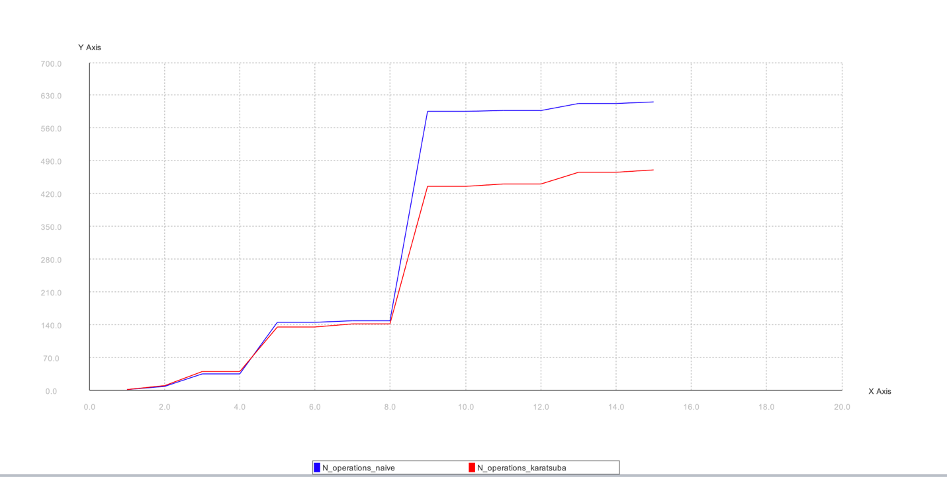

**Observations:**

It is observed that overall, the Karatsuba multiplication method is more efficient than the naïve multiplication method in most cases; where efficiency is determined by the “cost”, which is the number of arithmetic operations multiplied by the size (in bits) of the integers involved in this operation.

Initially, the naïve multiplication method is shown to be more efficient in the beginning, as its cost is less for a smaller size. But, past a size of 4, the Karatsuba multiplication method becomes more efficient because it makes fewer recursive calls, and less multiplication done as the size get bigger. Once the size of 9 is hit, the cost of each method starts to become more constant, with less of an increase in respect to the increase of bit size of the integers.

So, overall the Karatsuba multiplication method is more efficient, as it makes fewer recursive calls as the bit size increases.